1.Exact value=9.487735836358526
i)f(2.25)=9.496924999999997
ii)f(2.25)=9.496924999999999

2.a)
x₀=0.43
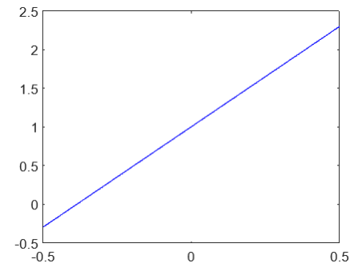

P(x)=2.5948x+1
P(x₀)=2.11579

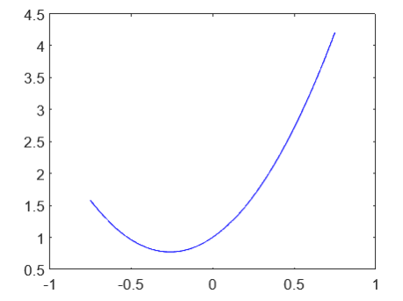
P(x)=3.3667x²+1.7532x+1
P(x₀)=2.3763825

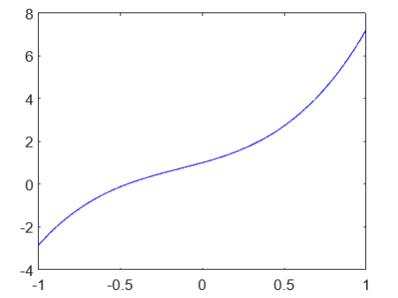

P(x)=2.9121x³+1.1826x²+2.1172x+1
P(x₀)=2.3606047

b)
x₀=-1/3
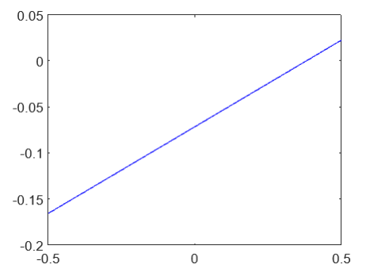

P(x)=0.1882x-0.0718
P(x₀)=-0.1345

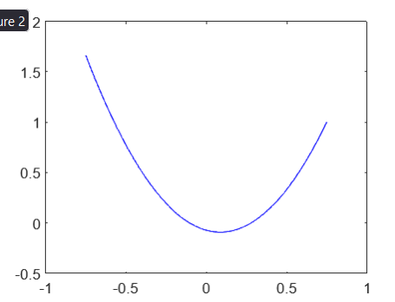
P(x)=2.5010x²-0.4370x-0.0718
P(x₀)=0.35174

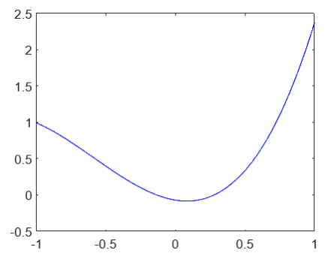
P(x)=x³+1.7510x²-0.3120x-0.0718
P(x₀)=0.1897

3)
f(1+√10)=0.0545715

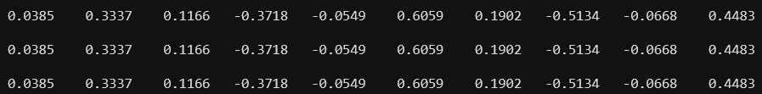
In the order of newton forward, newton backward and lagrange:

the behaviour of f(x)=1/(1+√x) is very different from any polynomial therefore it is not converging for any method

